Date: November 7, 2024
To: Weber County Board of County Commissioners
From: Ronna Tidwell
Community Development Department
Agenda Date: November 12, 2024
Subject: Request to Declare Parcel Number 19-024-0041 as Surplus Property
Attachments: A - Aerial Vicinity Map
B - Ownership Plat

_____________________________________________________________________________________

Summary:
A Weber County owned parcel of land, identified as Tax ID #19-024-0041, was acquired by the County through a tax sale process and deed executed in 1981. The parcel contains approximately 5288 sf and is located at the rear of 3648 W 2600 N in Plain City, UT. See Attachment A for a vicinity map and Attachment B for the County Recorder’s ownership plat map.
The County has been contacted by an adjacent property owner who has asked if the County would consider selling the subject parcel.
Weber County has no intended use for this property; therefore, it is recommended that the parcel be declared as surplus and offered to the adjacent property owner. In order to convey real property, the County Commission must first take action to declare this parcel as surplus property.

Property Description:

19-024-0041

PART OF THE SOUTHEAST QUARTER OF SECTION 28, TOWNSHIP 7 NORTH, RANGE 2 WEST, SALT LAKE BASE AND MERIDIAN, U.S. SURVEY: BEGINNING 63 RODS WEST AND 485 FEET NORTH OF THE SOUTHEAST CORNER OF SAID QUARTER SECTION, RUNNING THENCE NORTH 43 FEET, THENCE EAST 150.74 FEET, THENCE SOUTH 35 FEET, THENCE NORTH 88D05'15" WEST 40.45 FEET, THENCE WEST 61.48 FEET, THENCE SOUTH 81D08'26" WEST 47 FEET TO POINT OF BEGINNING.
Attachment A
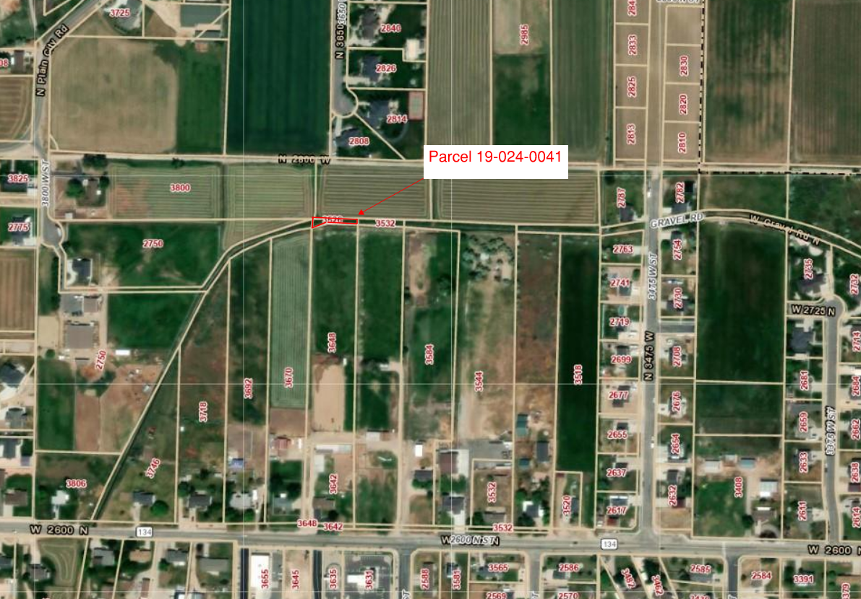

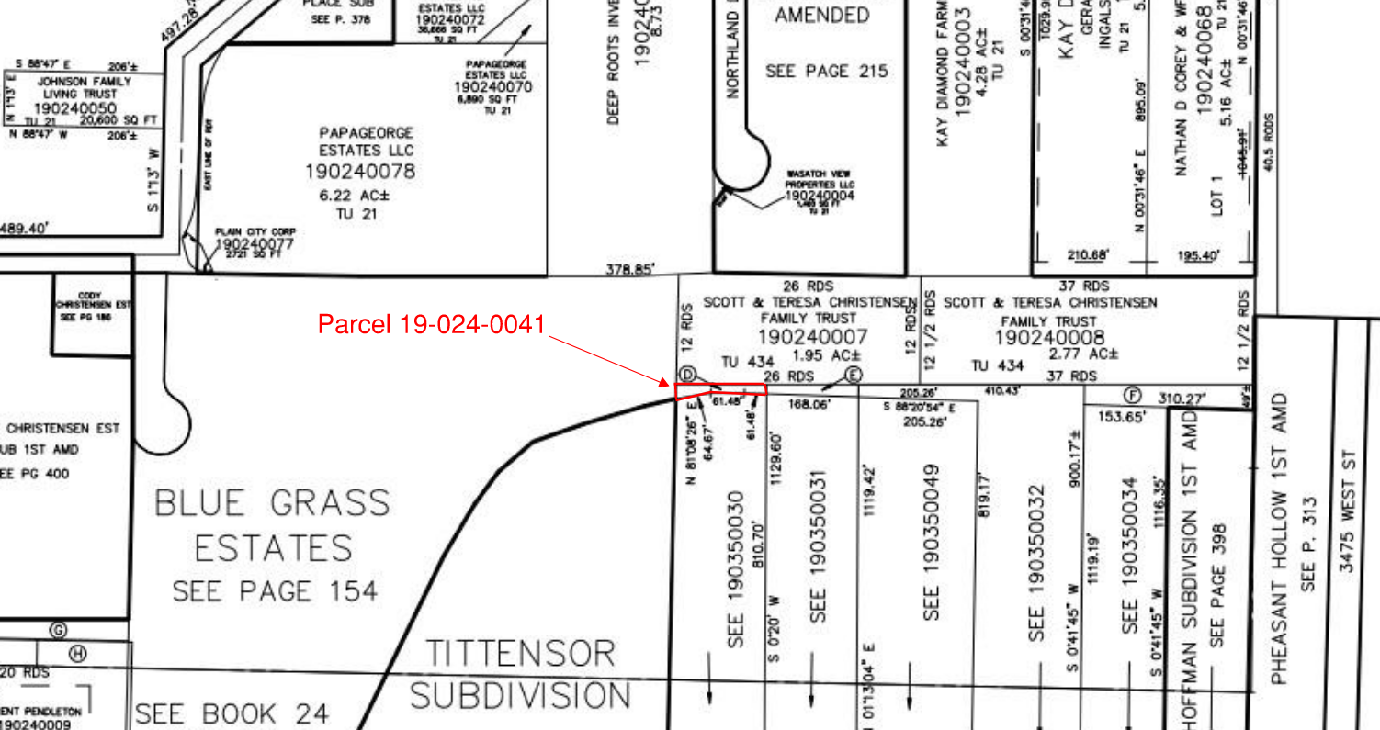
Attachment B

